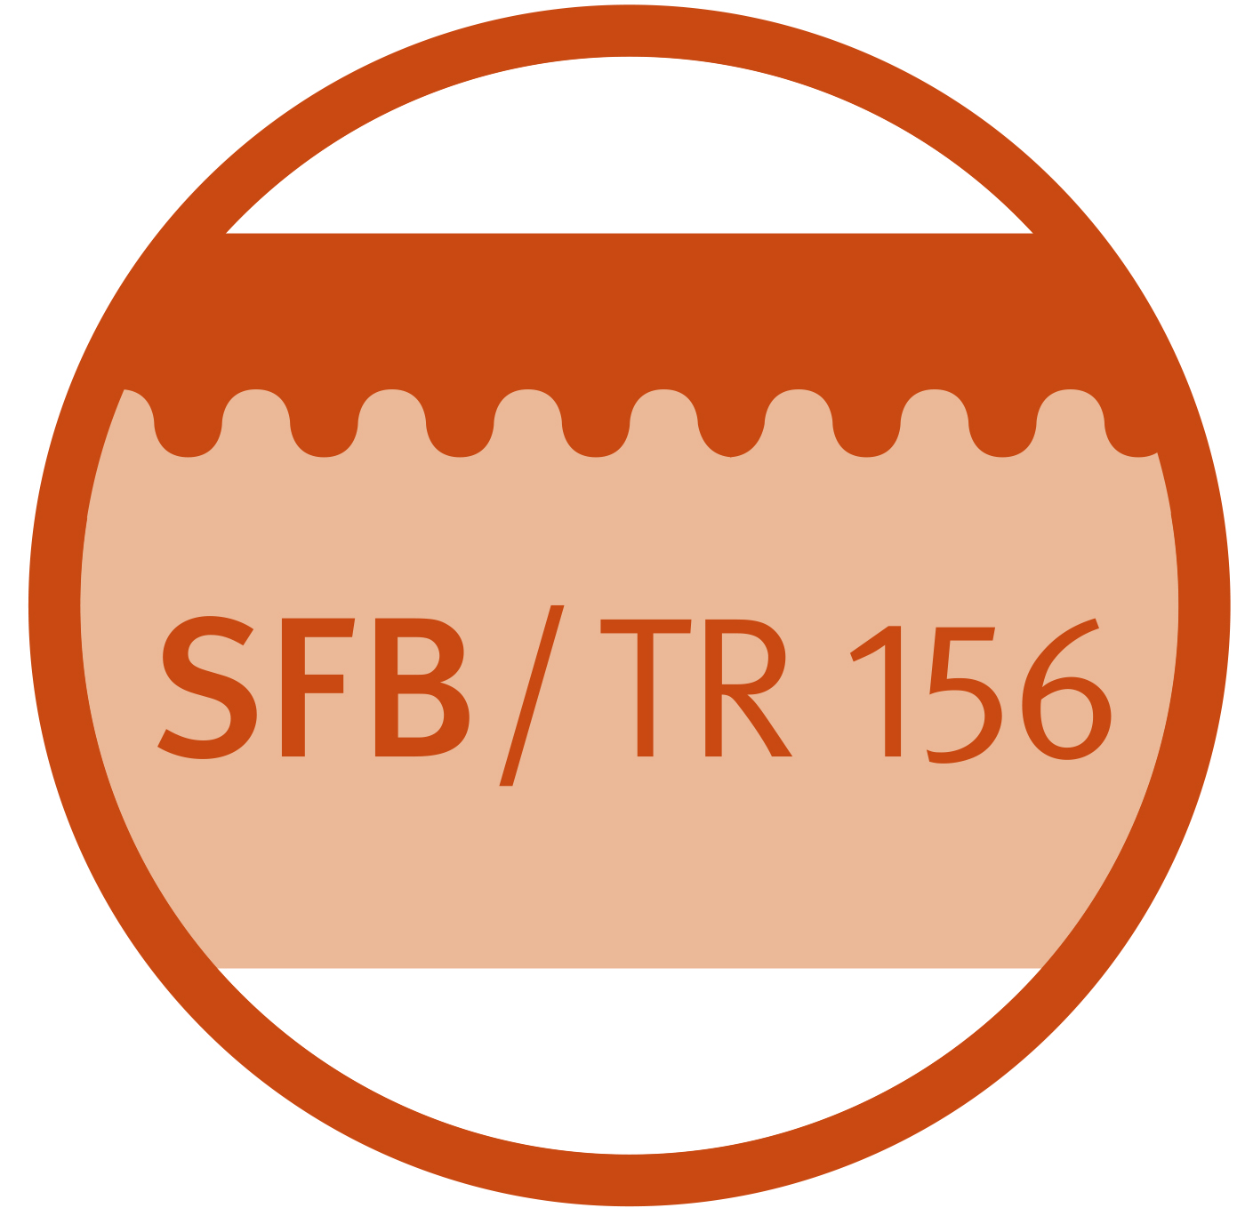
SFB TR156
11th research retreat
January 14th and 15th, 2021

PROGRAM

Thursday, 14.01.2021

8:25 am Welcome Enk

8:30 – 9:54 h Speed dating All projects

9:55 – 10:09 h Coffee break

10:10 – 11:53 h Speed dating All projects

11:54 – 12:44 h Lunch

12:45 – 13:53 h Speed dating All projects

14:30 – 15:30 h Wrap up All

Friday, 15.01.2021

8:30 h Project A08 Kretschmer

8:56 h Project B05 Weber

9:21 h Project B06 Röcken/Yazdi

9:46 h Coffee break

10:00 h Project C03 Kneilling/Pichler

10:26 h Project C06 Sandhoff/Nelson

10:51 h Project KS01 Radsak

11:30 h Wrap up and good bye

